Another proof that concrete can last 100+ years

The concrete industry often promotes its products as the most durable, allowing to maintain their structural and functional capacity during the whole life of the construction works (building or infrastructure) they are incorporated with. A recently published independent report by the Swedish water development agency confirms this claim and shows that public authorities, contractors and end users can fully trust the concrete industry for delivering sustainable and durable solutions for drainage systems that can last for at least 100 years.
If it was still necessary to demonstrate it, the outstanding performances over time of concrete pipes is proven by this report. CCTV inspections of existing systems in Sweden show that a large proportion of concrete installed more than one hundred years ago are still functional. Cities like Stockholm and Malmö, who trusted concrete producers more than a century ago, now have drainage system still functional under normal maintenance conditions. The massiv expansion in 1960-70 with concrete pipes of higher quality will then give even longer lifespan than 100 years, the report says. With such favorable findings, the concrete industry would welcome a comparison with other solutions. Unfortunately, no other examples of old systems made with other materials could be found.
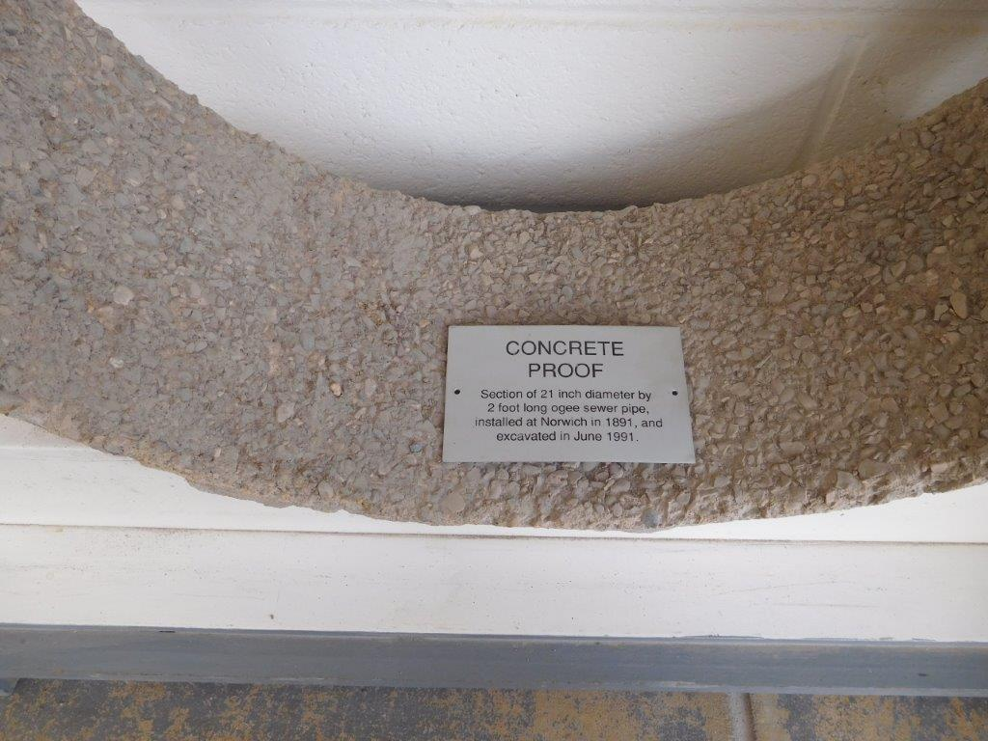

A European case
The Swedish case described in this report is not a special case. Other proofs of concrete drainage system withstanding 100 years of service life can be found throughout Europe, like this pipe section excavated in Norwich (UK)
Overmore, a lot of innovation is hidden in today pipes, as little as this may appear from the outside. Concrete formulations have not ceased to evolve during the years, as well as manufacturing systems, reinforcement solutions, surface treatments and joints. This evolution of concrete pipes is clearly demonstrated by the better performance of newer pipes compared to the old ones highlighted in the report.
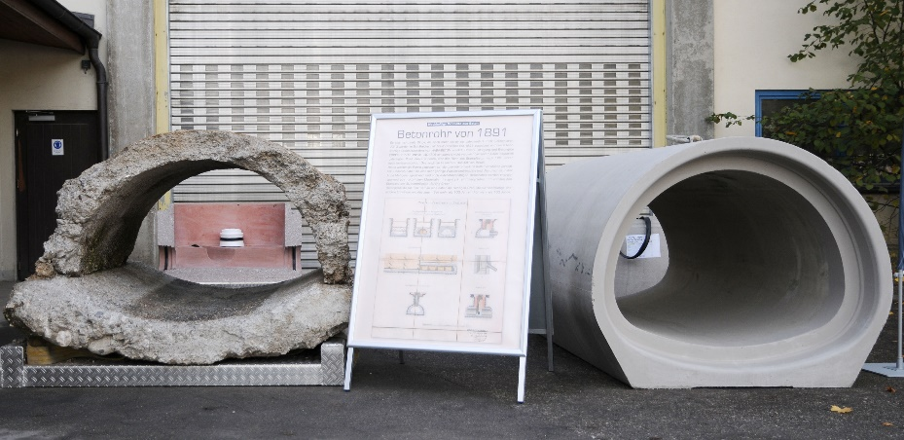

The same ... or not
Precast Concrete solutions have evolved over time to provide better solutions that last longer and longer

Cooperation amongst the different actors (producers, contractors, public authorities and water management agents) is identified as a key factor for the development of the sustainable drainage systems of tomorrow. When the drainage system is correctly designed and the installation is done properly, most of the identified problems can be avoided and a true sustainable system of 100-150 years lifetime can be achieved with concrete pipes.
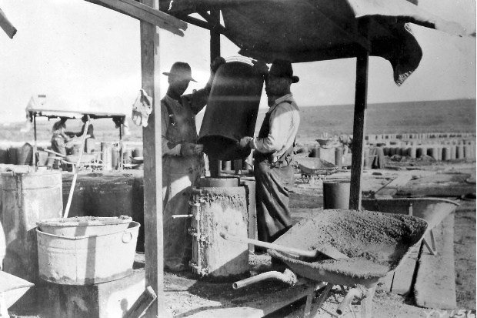

But the concrete industry is not simply sitting on its advantages. Every year, upgrades are made to the solutions provided and further research is ongoing to improve the already excellent behaviour, whilst maintaining a competitive price.

The Report
The purpose of this report is to improve the sustainability of pipe systems and enhance for the life span up to 100–150 years by through several actions. An in-depth analysis of the current distribution, wastewater and rainwater system is performed to create the bases for future actions. Several needs for further research are identified, but concrete pipe systems stand out for their proven durability in time, showing at the same time an increased quality with more recent solutions.

Framtidens hållbara VA-ledningssystem (Sustainable water and wastewater pipe system) - Helena Mårtensson, Annika Malm, Bror Sederholm, Jan-Henrik Sällström, Jan Trägårdh - Svenskt Vatten Utveckling, 2018-10 (Swedish Water Development)

